DATA ANALYTICS FOR HEALTHCARE

Team Id : PNT2022TMID04319

ASSIGNMENT 1:

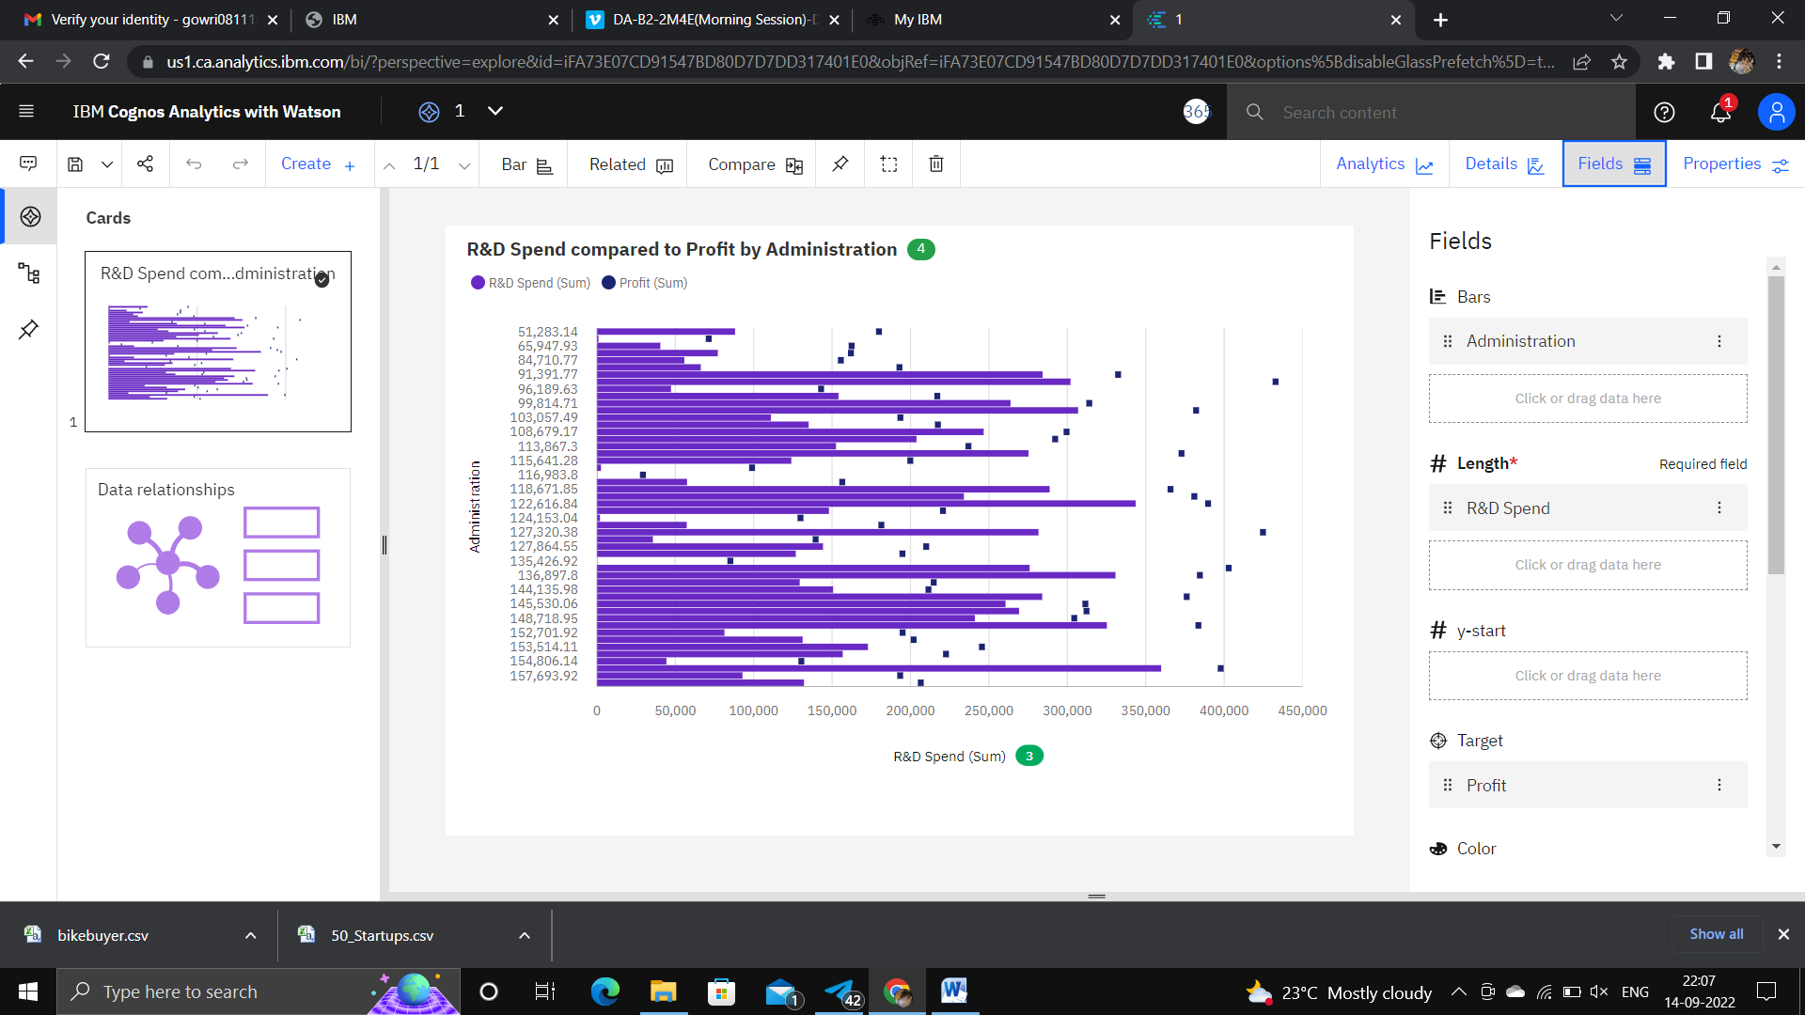

<https://us1.ca.analytics.ibm.com/bi/?perspective=explore&pathRef=.my_folders%2FAssessment%2F1&subView=model000001833c8b873a_00000000>

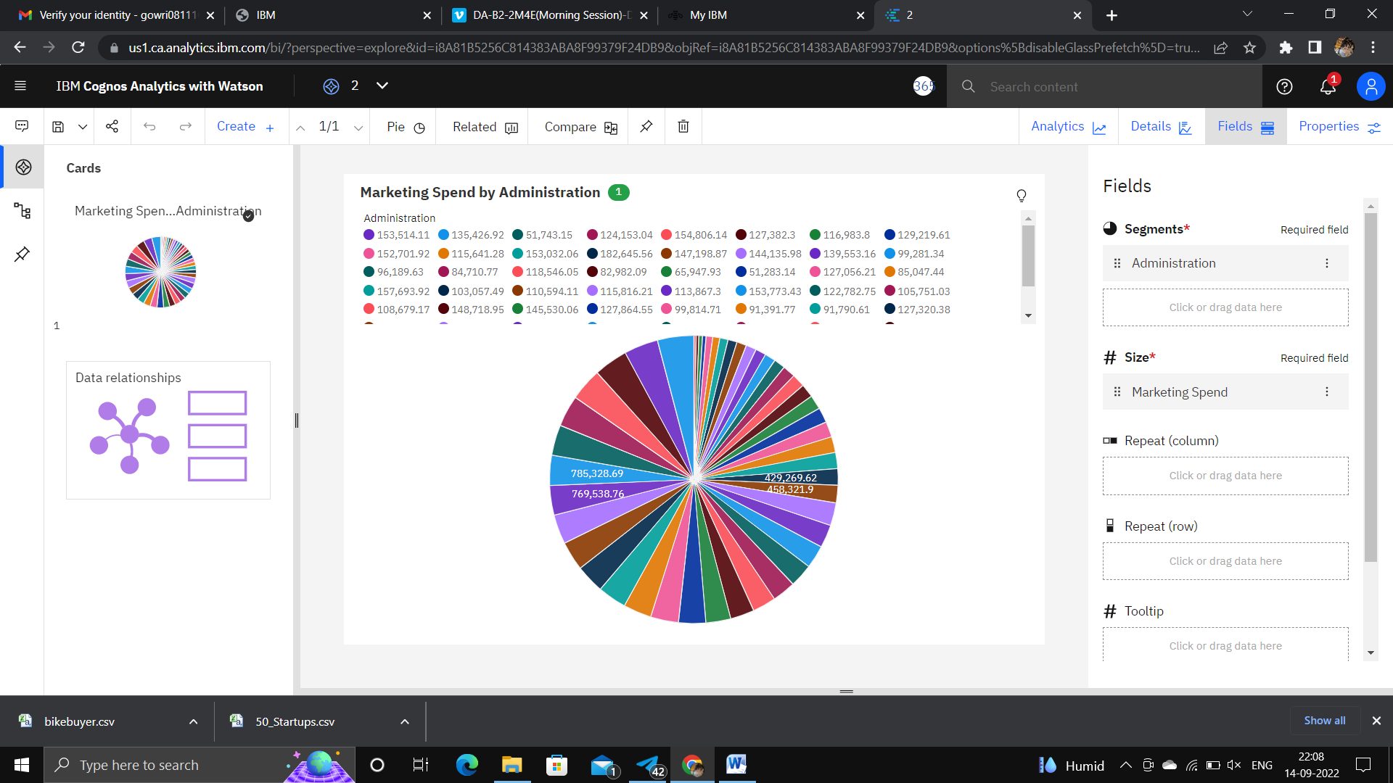

<https://us1.ca.analytics.ibm.com/bi/?perspective=explore&pathRef=.my_folders%2FAssessment%2F2&subView=model000001833cc68208_00000003>

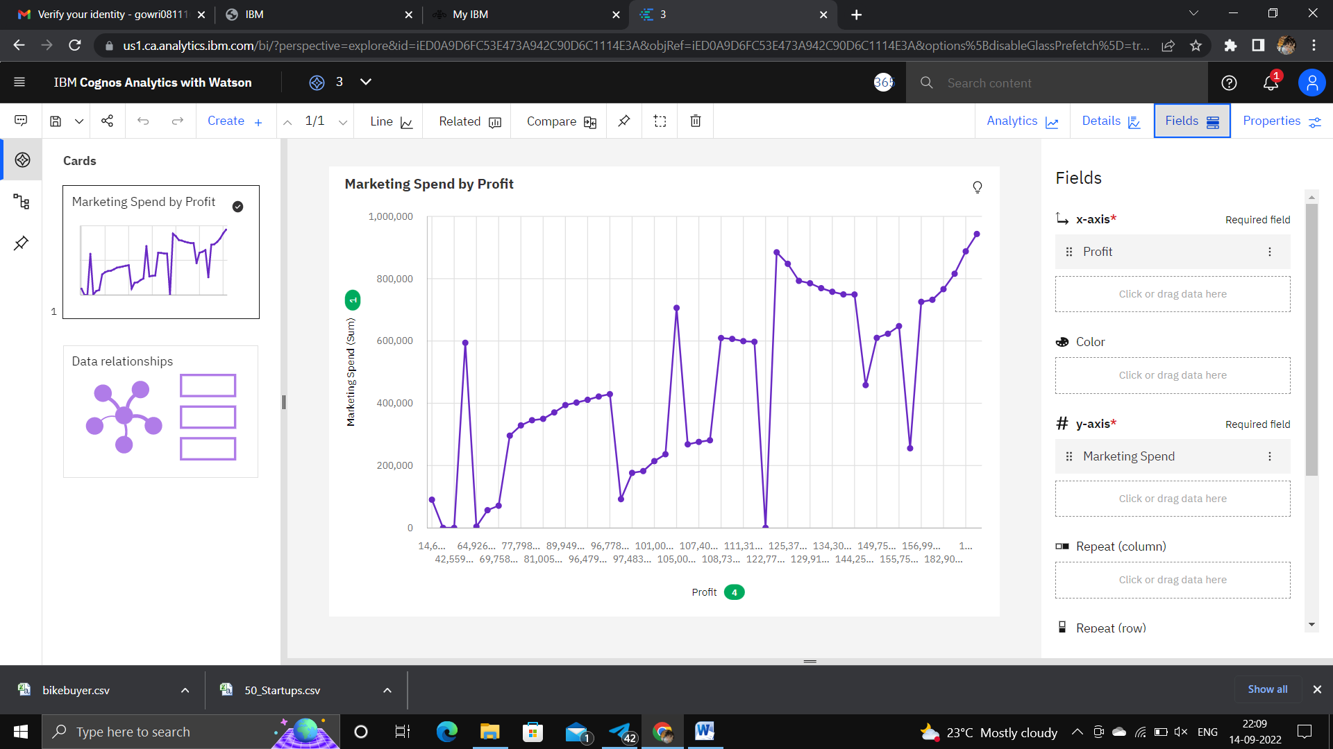

<https://us1.ca.analytics.ibm.com/bi/?perspective=explore&pathRef=.my_folders%2FAssessment%2F3&subView=model000001833cc8b401_00000002>

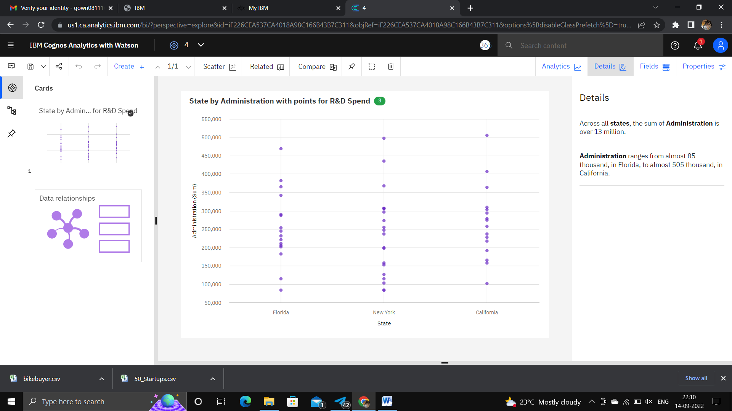

<https://us1.ca.analytics.ibm.com/bi/?perspective=explore&pathRef=.my_folders%2FAssessment%2F4&subView=model000001833cc9f4d5_00000000>

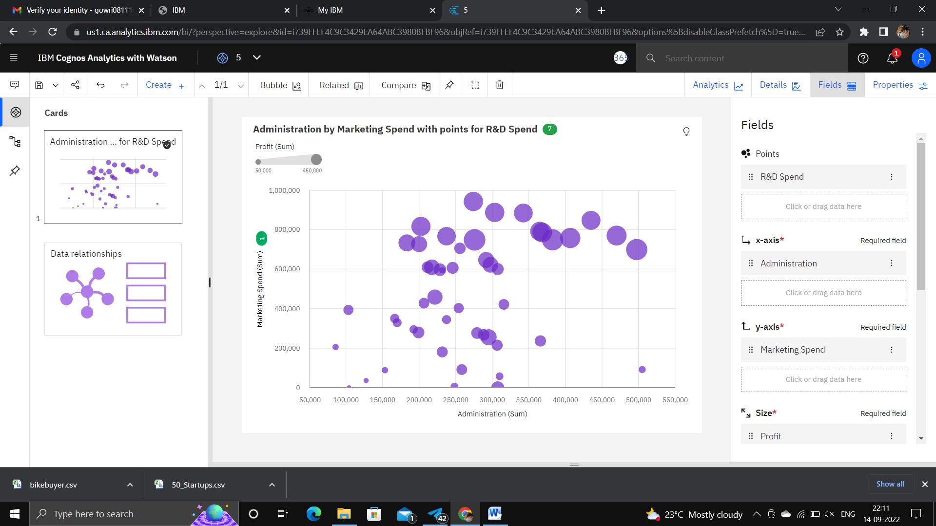

<https://us1.ca.analytics.ibm.com/bi/?perspective=explore&pathRef=.my_folders%2FAssessment%2F5&subView=model000001833cd21533_00000000>

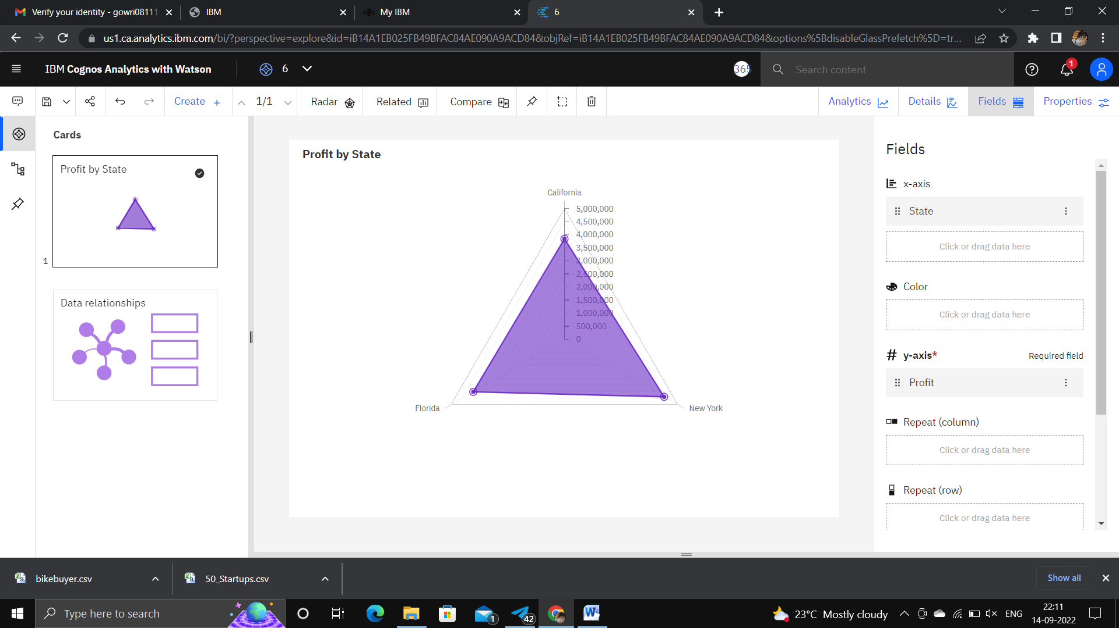

<https://us1.ca.analytics.ibm.com/bi/?perspective=explore&pathRef=.my_folders%2FAssessment%2F6&subView=model000001833cd41051_00000000>